Probability

Paper 1 Style Questions

1. The table below shows the number of left and right handed tennis players in a sample of 50 males and females.
 | Left handed | Right handed | Total
Male | 3 | 29 | 32
Female | 2 | 16 | 18
Total | 5 | 45 | 50

If a tennis player was selected at random from the group, find the probability that the player is

(a) male and left handed;
(b) right handed;
(c) right handed, given that the player selected is female.

Working:
Answers:
(a) …………………………………………..
(b) …………………………………………..
(c) …………………………………………..
(Total 4 marks)

2. A bag contains 2 red, 3 yellow and 5 green sweets.

Without looking, Mary takes one sweet out of the bag and eats it. She then takes out a second sweet.

(a) If the first sweet is green, what is the probability that the second sweet is also green?
(b) If the first sweet is not red, what is the probability that the second sweet is red?

Working:
Answers:
(a) …………………………………………..
(b) …………………………………………..
(Total 4 marks)

3. Today Philip intends to go walking. The probability of good weather (G) is . If the weather is good, the probability he will go walking (W) is 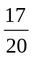. If the weather forecast is not good (NG) the probability he will go walking is .
(a) Complete the probability tree diagram to illustrate this information.
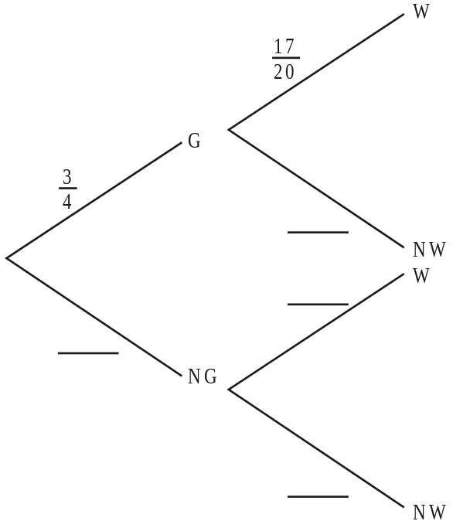

(b) What is the probability that Philip will go walking?
Working:
Answer:
(b) ..................................................................
(Total 8 marks)

Paper 2 Style Questions

4. Two jars contain a number of coloured balls as indicated in the diagrams below.
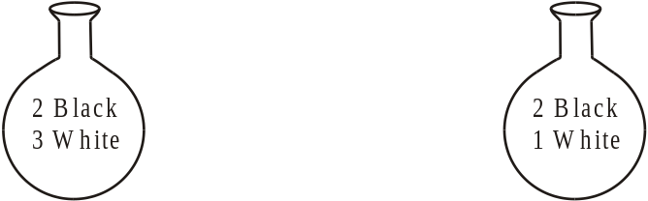
Jar One Jar Two
Two experiments are carried out.
First Experiment: A jar is first chosen at random and then a ball is drawn from that jar.
(a) Draw, and label fully, a tree diagram to show all possible outcomes of this experiment.
(2)
(b) What is the probability that a white ball is drawn?
(3)
Second Experiment: The ball drawn in the first experiment is not replaced. A second ball is then drawn from the same jar.
(c) What is the probability that both balls are white?
(2)
(Total 7 marks)

5. The data in the table below refers to a sample of 60 randomly chosen plants.
Growth rate | Classification by environment
↓ | dark | light | shady | total
high | 3 | 8 | 14 | 25
low | 8 | 9 | 18 | 35
total | 11 | 17 | 32 | 60
(a) (i) Find the probability of a plant being in a shady environment.
(ii) Find the probability of a plant having a low growth rate and being in a dark environment.
(iii) Find the probability of a plant not being in a dark environment.
(5)
(b) A plant is chosen at random from the above group.
Find the probability that the chosen plant has
(i) a high growth rate or is in a dark environment, but not both
(ii) a light environment, given that it has a high growth rate.
(4)
(c) The 60 plants in the above group were then classified according to leaf type. It was found that 15 of the plants had type A leaves, 37 had type B leaves and 8 had type C leaves.
Two plants were randomly selected from this group. Find the probability that
(i) both plants had type C leaves
(ii) neither of the plants had type B leaves.
(5)
(Total 14 marks)

6. Note: For this question, it is important that you show your working and explain your method clearly.
A box contains 10 coloured light bulbs, 5 green, 3 red and 2 yellow. One light bulb is selected at random and put into the light fitting of room A.
(a) What is the probability that the light bulb selected is
(i) green?
(1)
(ii) not green?
(1)
A second light bulb is selected at random and put into the light fitting in room B.
(b) What is the probability that
(i) the second light bulb is green given the first light bulb was green?
(l)
(ii) both light bulbs were not green?
(2)
(iii) one room had a green light bulb and the other room does not have a green light bulb?
(3)
A third light bulb is selected at random and put in the light fitting of room C.
(c) What is the probability that
(i) all three rooms have green light bulbs?
(2)
(ii) only one room has a green light bulb?
(3)
(iii) at least one room has a green light bulb?
(2)
(Total 15 marks)

Answers

Probability Homework 1

1. (a) 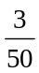 or 6 % or 0.06 (A1) (C1)
(b) 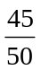 or 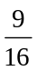 or 90 % or 0.9 (A1) (C1)
(c) 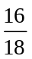 or or 0.889 (3 s.f.) (A2) (C2)
[4]

2. (a) (A2)
(b) (A2)
[4]

3.
(a)
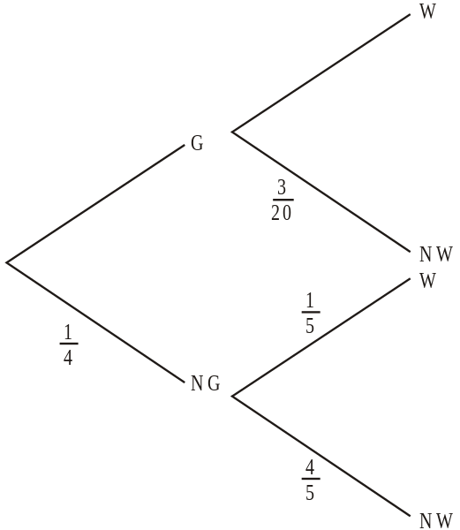 (A4) (C4)
(b) P (G ∩ W) = 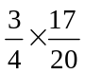 (A1)
P(NG ∩ W) = 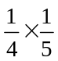 (A1)
P(W) = 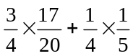 (M1)
= 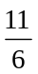 (0.6875, 68.75% or 0.688 to 3 significant figures) (A1) (C4)
[8]

4. (a)
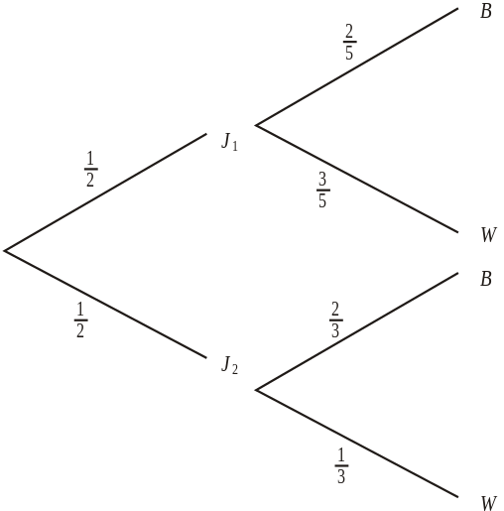 | (A1)  (A1) | 2
(b) P(J1 ∩ W) = 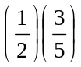, P(J2 ∩ W) = 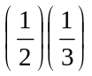 (M1)
P(W) = 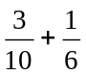= 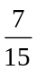 or 0.467 (3 s.f.) or 46.7 % (3 s.f.) (M1)(A1) 3
(c) P(J1 ∩ W ∩ W) = 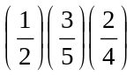, P(J2 ∩ W ∩ W) = 0 (M1)
P(W ∩ W) = 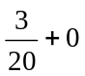= 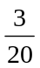 or 0.15 or 15% (A1) 2
[7]
5. Accept all answers given as percentages. If a correct fraction is seen as answer, ignore subsequent cancellations or decimal reductions (including AP’s) if incorrect.
(a) (i) P(shady) = 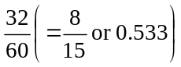 (A1)(A1)
(ii) P(dark and low growth rate) = 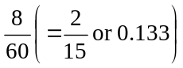 (A1)
(iii) P(not dark) = 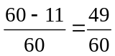(= 0.817) (A1)(A1) 5
(b) (i) P (high growth rate or dark environment)
= 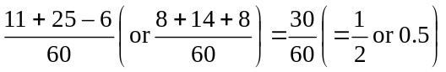 (A1)(A1)
(ii) P (in light, given high growth rate) = 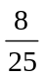 (= 0.32) (A1)(A1) 4
(c) (i) P(CC) = 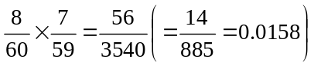 (M1)(A1) or (G2)
(ii) Three alternative valid approaches might be seen:
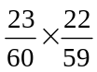 OR 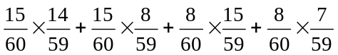
OR 1 – 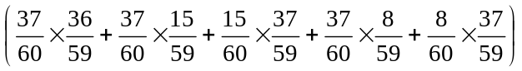 (M1)(A1)
= 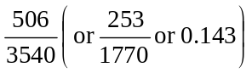 (A1) or (G3) 5
[14]

6. (a) (i) p(green) = 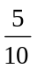 (A1)
(ii) p(not green) = (A1)
(b) (i) p(G⏐G) = or 0.444 (3 s.f.) (A1)
(ii) p(not green then not green)
= 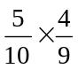= 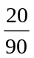 or or 0.222 (3 s.f.) (M1)(A1)
(iii) p(one green and one not green)
= 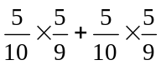= 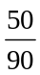 or or 0.556 (3 s.f.) (M2)(A1)
(c) (i) p(3 green) = 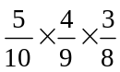= 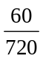 or 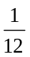 or 0.0833 (3 s.f.) (M1)(A1)
(ii) p(only one green) = 3 × 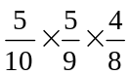 (M2)
= 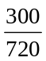 or 0.417 (3 s.f.) or 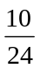 or 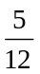 (A1)

(iii) p(at least one green) = 1 – p(no green)
= 1 – = 1 – = 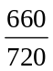 or 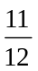 or 0.917 (3 s.f.) (M1)(A1)
[15]

